**School of Computer Science and Engineering**

**COMMERCE BANK PRO (Static Main)**

**BY**

**Introduction:**

Welcome to the CommerceBankpro Online Banking Platform User Guide! This document serves as an essential resource for navigating and maximizing the functionalities offered by CommerceBankpro, an all-encompassing online banking solution designed to provide users with a seamless and secure financial management experience.

CommerceBankpro boasts a collection of distinct pages, each meticulously crafted to cater to specific user needs. The "Register for the Account" page acts as the gateway for creating new banking accounts, while the "Sign In" page provides access to registered accounts, unlocking many services and features.

One of the central features, the "OpenBankAccount" page, streamlines the process of opening new accounts by efficiently capturing user-provided details and securely storing this information in a MySQL Workbench database. Another pivotal functionality, the "UPI Payment" page, empowers users to conduct fund transfers between accounts using unique primary keys called UPIIDs.

Additionally, the innovative "Split Payment" feature enables users to divide transaction amounts among multiple sources, leveraging the UPIID system for enhanced flexibility in financial transactions. A comprehensive "Dashboard" consolidates these functionalities, offering users an insightful overview of their transactions and profile details.

The system ensures the utmost reliability and security by securely storing all information and user data within the robust MySQL database, reflecting CommerceBankpro's commitment to providing a user-friendly, secure, and efficient online banking experience.

**Users:** CommerceBankpro focuses on user ease via "Register for the Account" and "Sign In." "OpenBankAccount" ensures secure setup; "UPI Payment" and "Split Payment" offer flexibility; the "Dashboard" aids efficient financial management.

**Customers:** CommerceBankpro prioritizes customer satisfaction by providing a secure and user-friendly banking environment. The platform's seamless functionalities enable customers to perform various financial activities with ease, ensuring a positive and efficient banking experience.

**Developers:** This guide details CommerceBankpro's architecture, aiding developers in understanding system integration. Selenium tools guarantee rigorous testing, ensuring a robust and dependable platform.

**Project Managers:** This guide is essential for project managers, offering a comprehensive overview of functionalities and technology stack, aiding informed decision-making and efficient platform development and maintenance oversight.

**Maintenance Programmers:** This guide provides vital insights, aiding maintenance programmers in understanding system structure, and data storage, enabling efficient troubleshooting and updates.

This user guide aims to familiarize you with each facet of CommerceBankpro, guiding you through its functionalities and empowering you to manage your finances conveniently and securely. Explore the subsequent sections to harness the full potential of this comprehensive online banking platform.

**Design Goals:**

1. **User-Centric Approach:** Prioritize user experience by ensuring intuitive navigation and user-friendly interfaces across all pages to facilitate ease of use for various functionalities.
2. **Security and Data Integrity:** Ensure robust security measures to safeguard user data stored in the MySQL Workbench database, adhering to industry standards and encryption protocols to prevent unauthorized access or breaches.
3. **Functionality and Flexibility:** Offer a comprehensive range of functionalities including account registration, fund transfers, and transaction splitting to provide users with versatile and efficient financial management options.
4. **Seamless Integration:** Create a cohesive platform where distinct pages operate harmoniously, ensuring smooth transitions between "Register for the Account," "Sign In," "OpenBankAccount," "UPI Payment," "Split Payment," and the "Dashboard" for a seamless user experience.
5. **Reliability and Performance:** Maintain high system reliability and performance to handle concurrent user interactions without compromising on response times or system stability.
6. **Automated Testing and Quality Assurance:** Utilize Selenium and Selenium IDE to conduct rigorous automated testing, ensuring consistent functionality and identifying and resolving potential issues proactively.

**System Behavior:**

1. **"Register for the Account" Page Behavior:**
   * Enables users to input necessary information to create new banking accounts securely.
   * Validates user inputs and ensures data accuracy before storing them in the MySQL database.
2. **"Sign In" Page Behavior:**
   * Authenticates registered users securely, granting access to the platform's services upon successful verification.
   * Provides a seamless transition to the Dashboard for managing accounts and transactions.
3. **"OpenBankAccount" Page Behavior:**
   * Captures user-provided details for opening new accounts, ensuring data security during input and storage processes.
   * Utilizes robust encryption techniques to safeguard sensitive user information in the MySQL database.
4. **"UPI Payment" and "Split Payment" Page Behavior:**
   * Facilitates secure fund transfers and transaction splitting between accounts using unique UPIIDs for identification and verification.
   * Ensures accurate and efficient transaction processing while maintaining the integrity of financial data.
5. **"Dashboard" Behavior:**
   * Aggregates and presents an overview of user transactions and profile details in an easily comprehensible format.
   * Provides users with a centralized platform for managing various banking functionalities seamlessly.

**UML Diagrams:**

**Work Breakdown Structure (WBS):**

**USE-CASE DIAGRAM:**

* Actors: Users,
* Use Cases: Register for Account, Sign In, Open Bank Account, UPI Payment, Split Payment, Dashboard
* Relationships between actors and use cases depicting interactions.

**Analysis model:**

* Analyzing requirements, functional and non-functional aspects.
* Identifying entities, relationships, and attributes related to banking functionalities.
* Determining user scenarios and system behavior.

**Sequence Diagram:**

* Describing the sequence of interactions between actors (users) and the system for specific functionalities like Register for Account, UPI Payment, etc.

**Class Diagram:**

* Defining classes such as Account, User, Transaction, etc., and their attributes and relationships.
* Depicting the structure of the CommerceBankpro system in terms of classes and their associations.

**Time Diagram:**

* Showing time-based aspects like the duration for different processes such as account registration, payment processing, etc.
* Illustrating the timelines for various actions performed by users within the system.

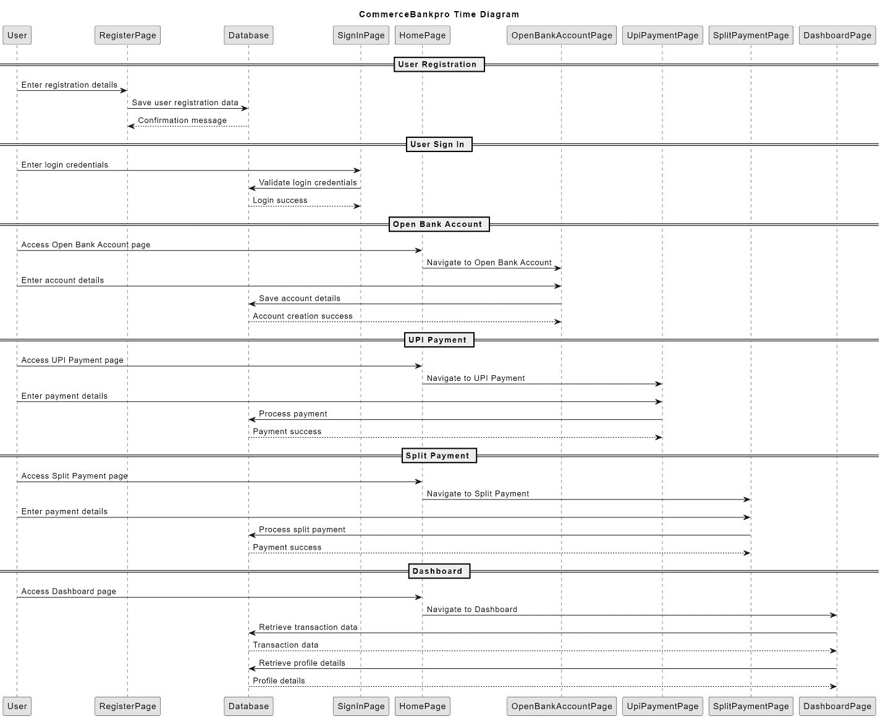

**Object Diagram:**

* Representing specific instances of classes and their relationships at a particular point in time, illustrating real-world objects and their interactions.

**State Machine Diagram (User):**

* Demonstrating the different states a specific object or system can transition through in response to events or actions.

**Data Flow Diagram:**

* Displaying how data moves through the system, from input (e.g., user actions) to processes (e.g., transactions) to output (e.g., Dashboard display).

